Pronoun

🟣 What is a Pronoun?
# Source: Chatgpt (GPT-4-turbo) at [7/24/2025]
A pronoun is a word that takes the place of a noun in a sentence.
We use pronouns to avoid repeating nouns and to make sentences clearer and smoother.

📘 Definition:
# Source: Chatgpt (GPT-4-turbo) at [7/24/2025]
A pronoun is a word used instead of a noun to avoid repetition. It refers to people, things, or ideas already known or mentioned.

🧠 Examples of Pronouns:
# Source: Chatgpt (GPT-4-turbo) at [7/24/2025]
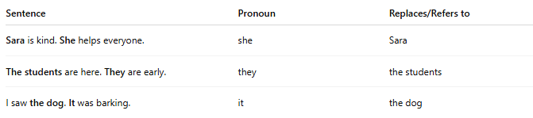
Sentence | Pronoun | Replaces/Refers to
Sara is kind. She helps everyone. | she | Sara
The students are here. They are early. | they | the students
I saw the dog. It was barking. | it | the dog

✳️ Types of Pronouns:
# Source: Chatgpt (GPT-4-turbo) at [7/24/2025]
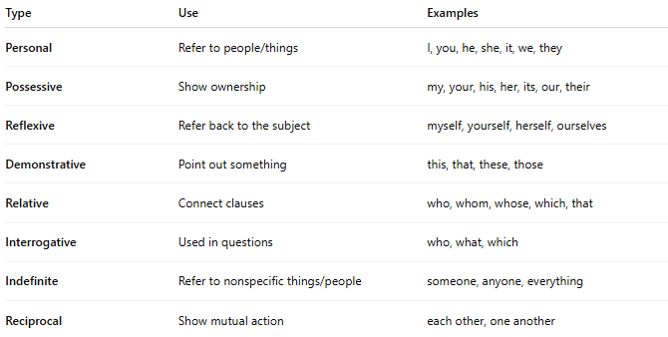

Type | Use | Examples
Personal | Refer to people/things | I, you, he, she, it, we, they
Possessive | Show ownership | my, your, his, her, its, our, their
Reflexive | Refer back to the subject | myself, yourself, herself, ourselves
Demonstrative | Point out something | this, that, these, those
Relative | Connect clauses | who, whom, whose, which, that
Interrogative | Used in questions | who, what, which
Indefinite | Refer to nonspecific things/people | someone, anyone, everything
Reciprocal | Show mutual action | each other, one another

🧾 Pronouns in Sentences:
# Source: Chatgpt (GPT-4-turbo) at [7/24/2025]
- He is my brother. (personal)
- This is her book. (possessive)
- She made it herself. (reflexive)
- These are my shoes. (demonstrative)
- The boy who called you is my friend. (relative)
- Who is knocking at the door? (interrogative)
- Someone is waiting for you. (indefinite)

✅ Summary:
# Source: Chatgpt (GPT-4-turbo) at [7/24/2025]
A pronoun is a word that replaces a noun to avoid repetition and make language easier and smoother.

